Check in command prompt.

Open command prompt

run (Windows +R) -> cmd

>git

It should be something like this

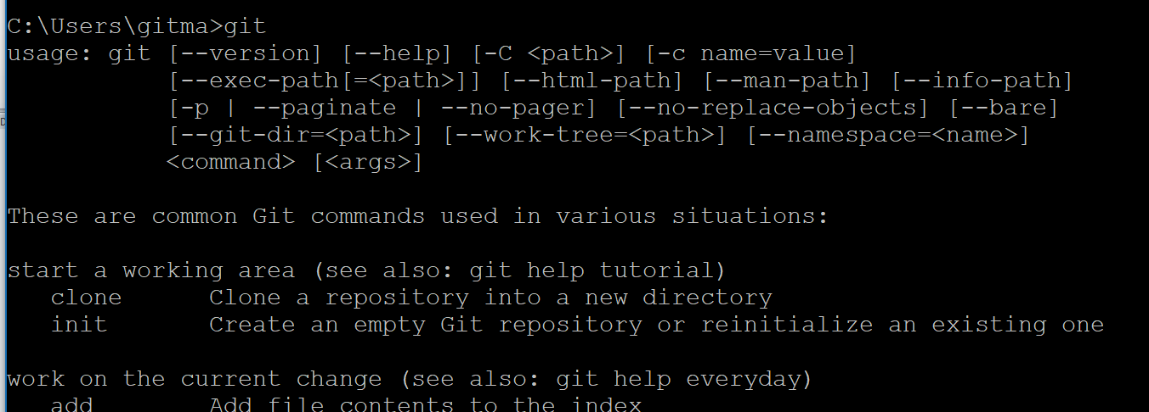

In your system:

Create folder

Ex: D:\Projects

Then Follow this

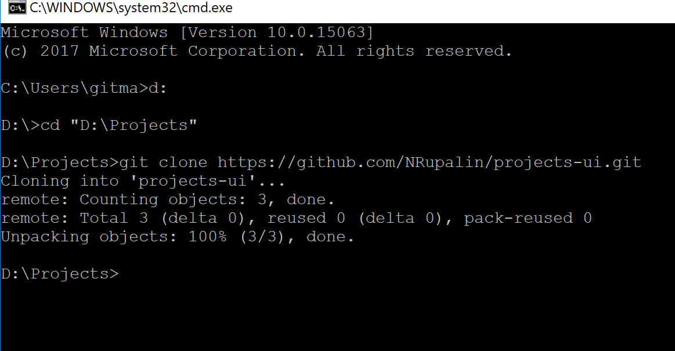

Run this command:

git clone https://github.com/NRupalin/projects-rupalin.git